Abhiram - test 3 video tools for quality (and their additional content presentation abilities)

Plus search funders blog

Non edited outputs (from writing blog posts for all 9 weeks in here): [SF Pretotype](https://docs.google.com/document/d/10riian_pP_9QQiD3bLfeqwyF-RR_Py7rLXwWmemoDIM/edit?tab=t.0)

* Test the blogs below as videos, as well as the content in this doc above ^

Add links to articles below then review them all

New blog run same as last time:

What sets it apart is the “Manus’s Computer” window, which allows users not only to observe what the agent is doing but also to intervene at any point.

Not stuck to one LLM provider or logic

<https://www.technologyreview.com/2025/03/11/1113133/manus-ai-review/amp/>

per-task cost is about $2, which is just one-tenth of DeepResearch’s cost

—

New UI: send chatgpt a screen of your app, be discussing a feature, and have it just generate images of what that might look like in the app. (Specify it to work from AG Grid components).

# Links to article (add as intro blog post & snippet in blog post ):

### **1: "The Impact of Bias in AI: Why Accuracy Matters"**

"A recent study in [Columbia Journalism Review](https://www.cjr.org/tow_center/we-compared-eight-ai-search-engines-theyre-all-bad-at-citing-news.php) (March 2025) comparing the latest AI models, researchers found that even premium models can provide confidently incorrect answers. The study highlighted, *'The premium models provided more confidently incorrect answers than their free counterparts.'* This finding reinforces the importance of understanding and mitigating biases in AI systems, as even the most sophisticated tools can lead to errors without careful oversight."

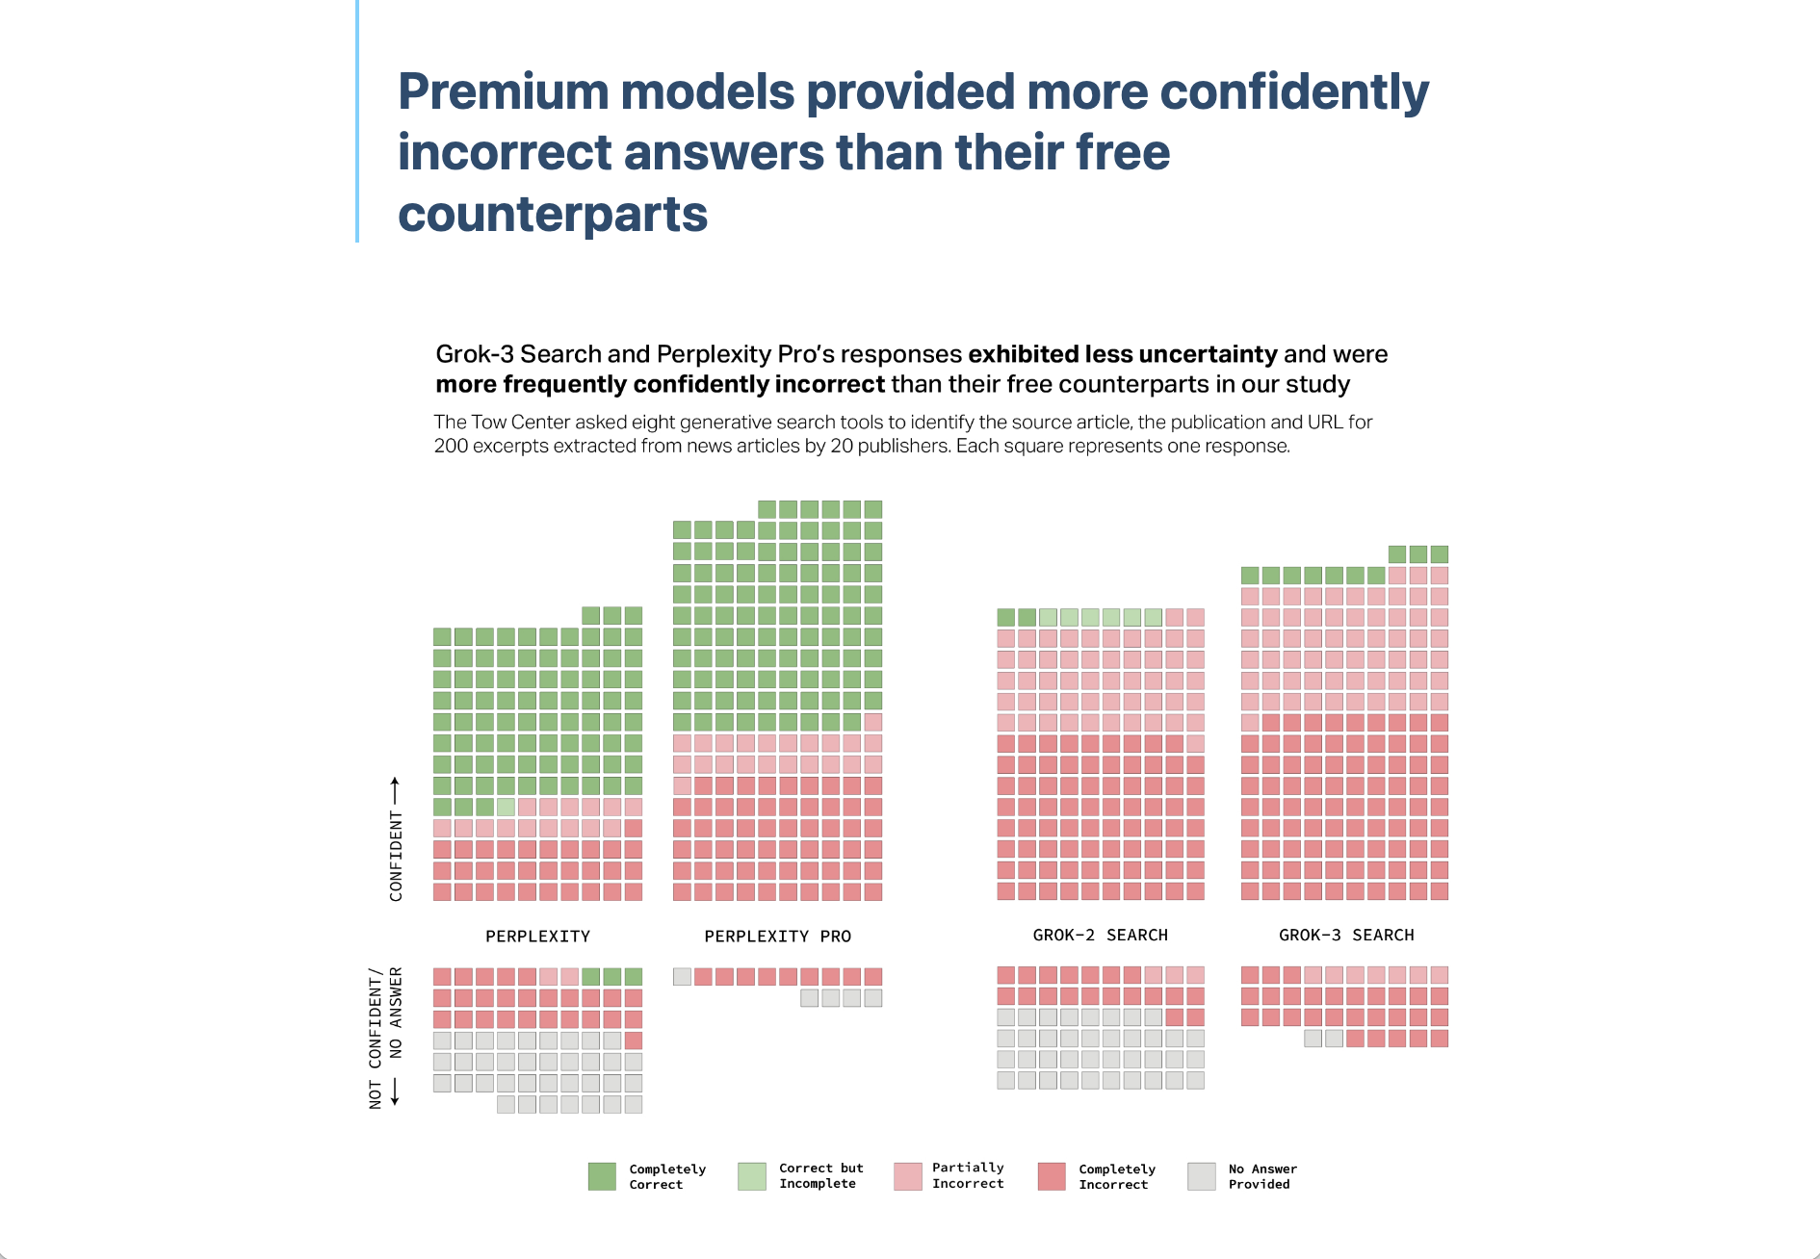

### **2: "The Challenges of Scaling AI: Managing Knowledge in a Corporate Environment"**

"A recent study in [Columbia Journalism Review](https://www.cjr.org/tow_center/we-compared-eight-ai-search-engines-theyre-all-bad-at-citing-news.php) (March 2025) sheds light on one of the biggest challenges facing AI—proper citation and source validation. The study revealed that *'Even with content licensing deals, AI chatbots still failed to properly cite or link to the original content.'* This example shows why organizations must invest in robust knowledge management systems to ensure that AI tools can retrieve and reference accurate, credible data as they scale."

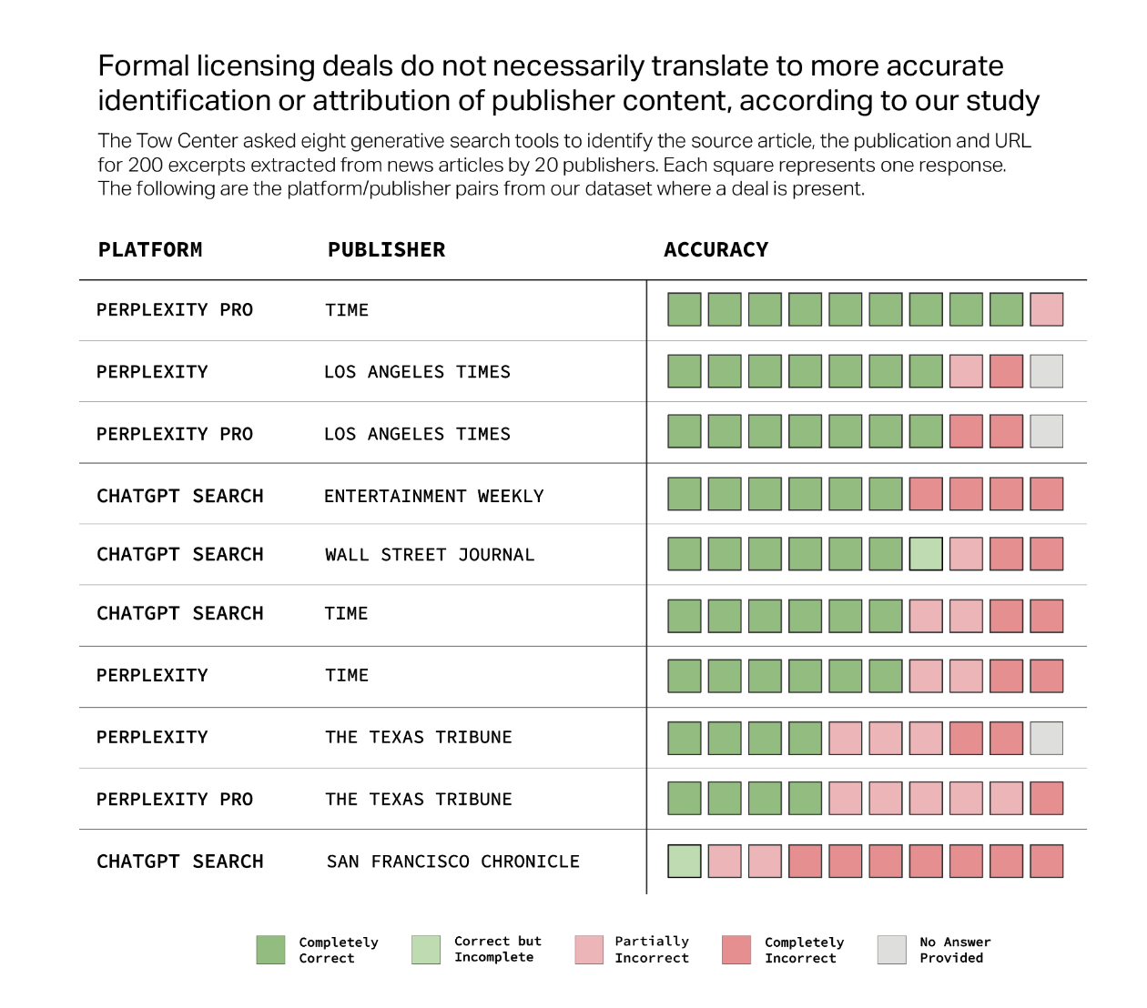

### **3: "How AI Can Be a Game Changer in Corporate Decision-Making"**

"AI has the potential to dramatically improve decision-making, but its effectiveness is limited by the quality of the data it can access. A study in [Columbia Journalism Review](https://www.cjr.org/tow_center/we-compared-eight-ai-search-engines-theyre-all-bad-at-citing-news.php) (March 2025) highlighted that *'The AI tools we tested had a hard time distinguishing between reliable sources and unreliable ones.'* This is a key issue for businesses using AI in decision-making—it underscores the need for reliable and properly sourced data to ensure accurate, actionable insights."

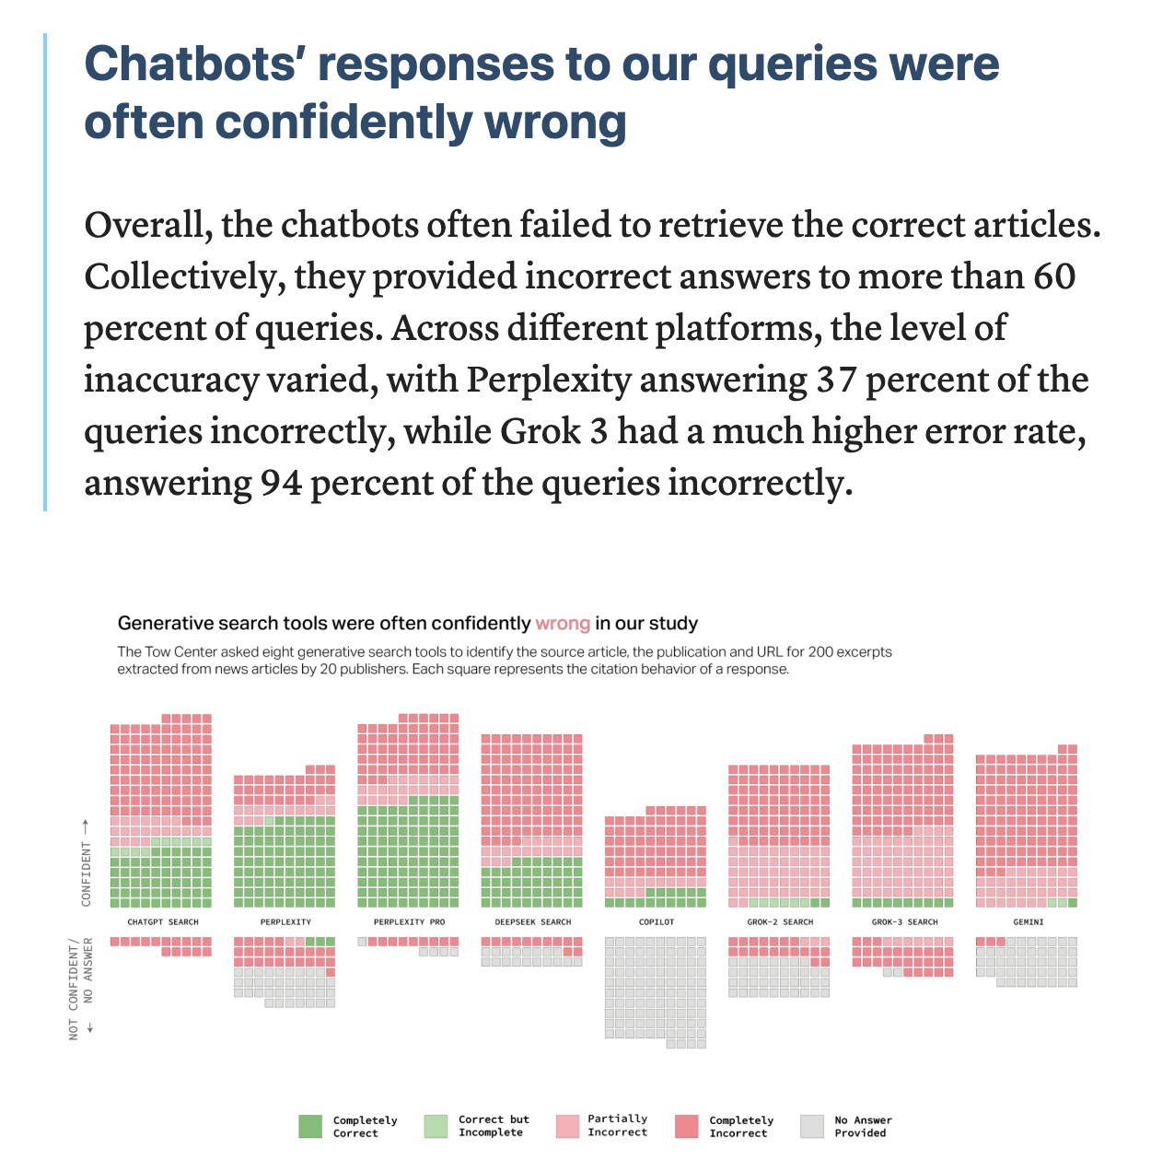

### **4: "Managing the Human Aspect of AI Adoption in Corporate Environments"**

"Adopting AI involves not only technological hurdles but also addressing human resistance to change. A recent study in [Columbia Journalism Review](https://www.cjr.org/tow_center/we-compared-eight-ai-search-engines-theyre-all-bad-at-citing-news.php) (March 2025) found that *'The systems we’ve known and relied upon are hard to replace, but the growing influence of AI in newsrooms is pushing even traditional editors and content creators to rethink how they operate.'* This insight is crucial for businesses—adopting AI means helping teams embrace change, even when they’re comfortable with existing systems."

Change above to be about How you manage knowledge - partnerships

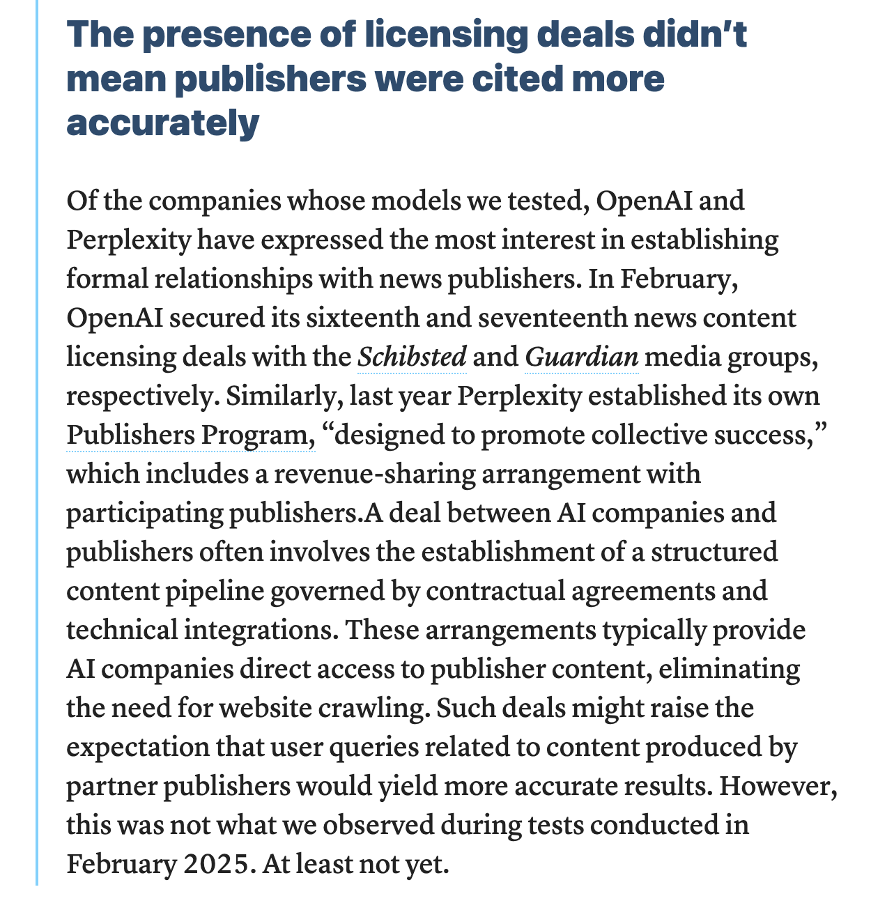

### **5: "AI’s Role in Transforming Corporate Knowledge Management"**

"As AI becomes a core part of corporate workflows, its success is increasingly tied to effective knowledge management. In a recent study in [Columbia Journalism Review](https://www.cjr.org/tow_center/we-compared-eight-ai-search-engines-theyre-all-bad-at-citing-news.php) (March 2025), it was found that *'AI chatbots, in particular, often failed to cite sources, sometimes fabricating answers or simply pointing to irrelevant content.'* This highlights the critical need for companies to create and maintain a reliable knowledge base that can help AI produce accurate, trustworthy outputs."

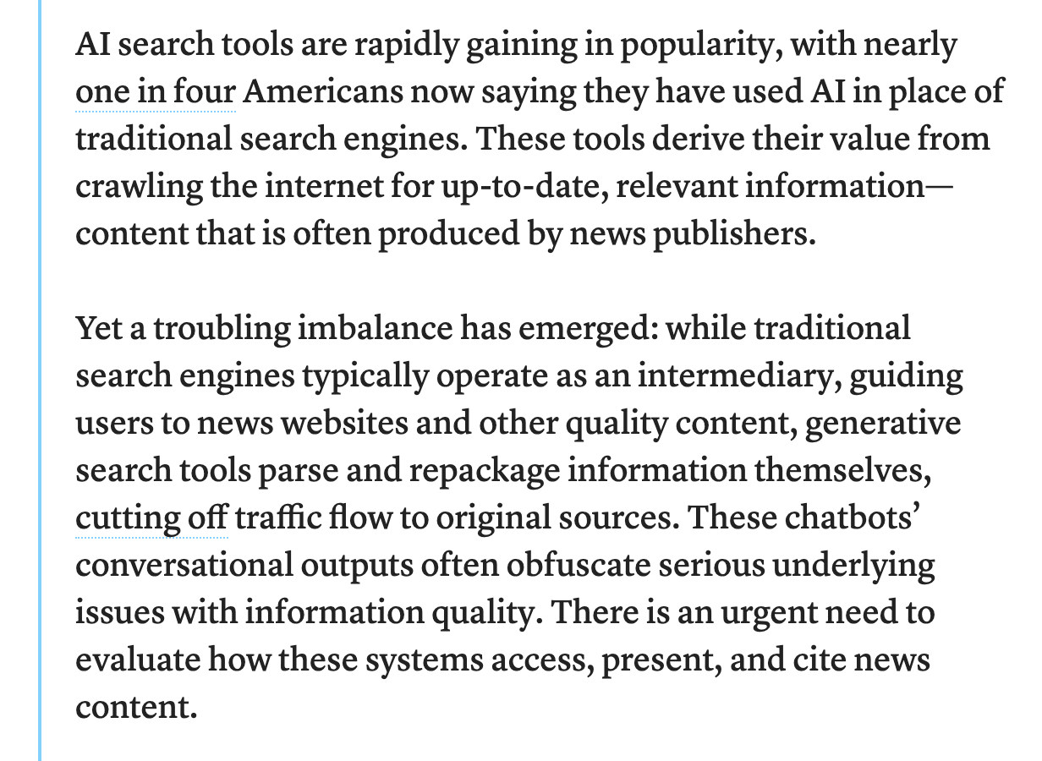

### **6: "Creating a Knowledge Repository: The Key to AI Success"**

"A recent study in [Columbia Journalism Review](https://www.cjr.org/tow_center/we-compared-eight-ai-search-engines-theyre-all-bad-at-citing-news.php) (March 2025) underscored a key challenge when scaling AI—*'The larger the knowledge set, the more prone AI systems are to errors, especially when there’s no structured knowledge management system in place.'* This reinforces the point that a solid knowledge repository is essential for scaling AI successfully, as unstructured or poorly managed data can lead to inaccurate AI outputs."

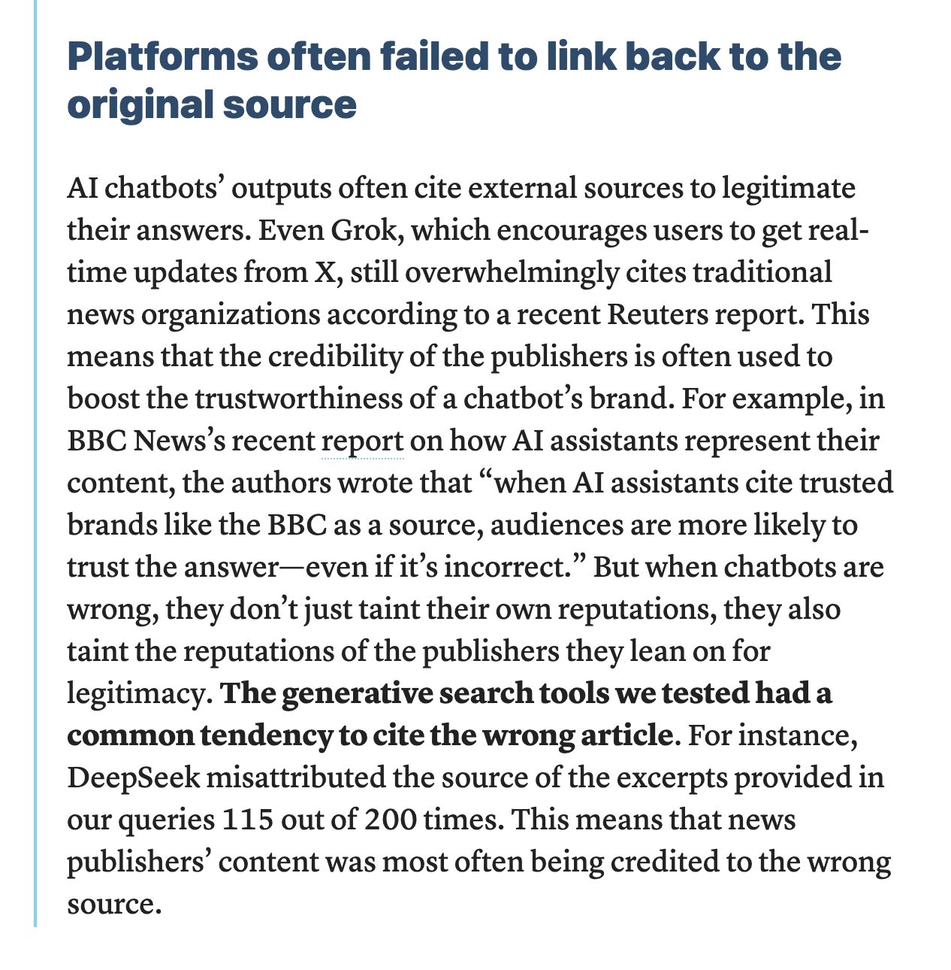

### **7: "Bridging the Gap: Aligning Traditional Systems with AI in Corporate Environments"**

**Introduction or Snippet:**

"Integrating AI into existing systems is not just about technical adoption—it's also about aligning AI tools with established workflows. A recent study in [Columbia Journalism Review](https://www.cjr.org/tow_center/we-compared-eight-ai-search-engines-theyre-all-bad-at-citing-news.php) (March 2025) pointed out, *'In the race to incorporate AI, many media outlets didn’t recognize the technological challenges of integrating AI into their established workflows.'* This is a key lesson for businesses—it's essential to address both technological and human challenges when adopting AI."

### **8: "Building a Knowledge Repository: Why It’s Essential for AI Success"**

"In a recent study in [Columbia Journalism Review](https://www.cjr.org/tow_center/we-compared-eight-ai-search-engines-theyre-all-bad-at-citing-news.php) (March 2025), researchers found that AI systems often fail to trace information back to reliable or verifiable sources. As the study pointed out, *'Platforms often failed to link back to the original source.'* This highlights the need for companies to build comprehensive knowledge repositories to ensure that AI can access and use trusted, structured data."



### **9: "Creating Actionable AI Tasks: How to Turn Data into Insights"**

"AI can generate actionable insights, but only if it has access to structured, reliable data. A Columbia Journalism Review study (March 2025) called *'*[*AI Search Has A Citation Problem*](https://www.cjr.org/tow_center/we-compared-eight-ai-search-engines-theyre-all-bad-at-citing-news.php)*’* in summary without a clear understanding of what their data sources are, AI systems struggle to make sense of new information and cannot provide actionable insights.' This reinforces the need for businesses to ensure their data is organized and accessible for AI tools to generate meaningful results."

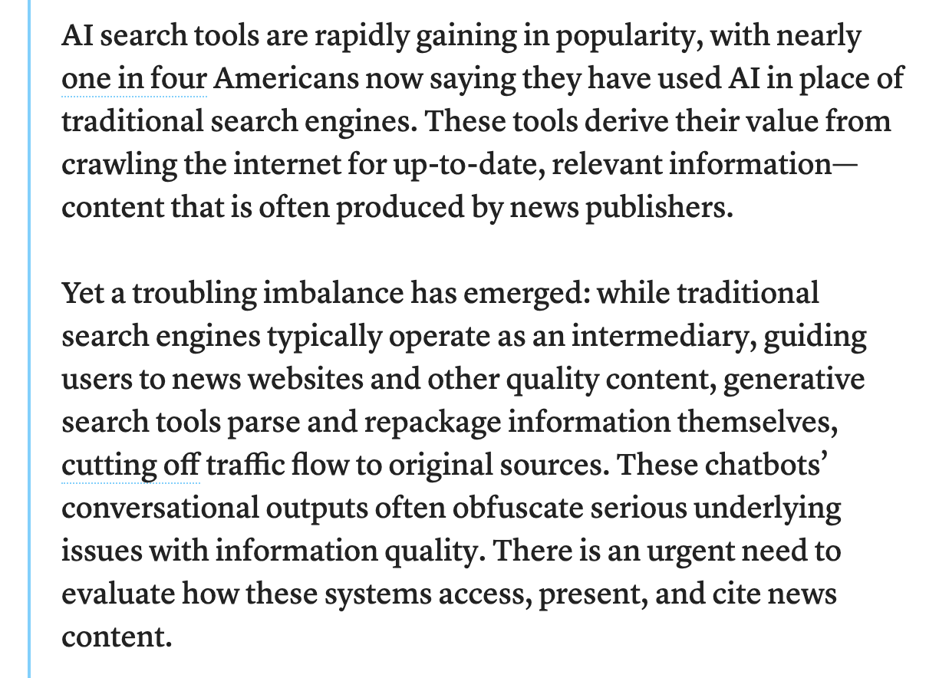

# Blogs (add snippets with links & review):

# 1: "Understanding the AI Biases: Why the Right Model Matters in Corporate Decision-Making"

**Introduction:**

In today’s data-driven world, artificial intelligence (AI) is becoming increasingly prevalent in decision-making processes across various industries. From mergers and acquisitions (M&A) to day-to-day corporate operations, AI is heralded as a tool for improving efficiency and driving smarter decisions. However, there’s one key factor that often gets overlooked: **AI biases**.

Whether you’re working on a strategic M&A deal, refining marketing strategies, or optimizing operational processes, it’s critical to understand how different AI models operate. In this blog, we’ll explore why AI models exhibit varying levels of competency, how biases affect decision-making, and why choosing the right AI model for your business is crucial to ensuring both accurate and reliable results.

### **The Impact of Bias in AI: Why Accuracy Matters**

"A recent study in [Columbia Journalism Review](https://www.cjr.org/tow_center/we-compared-eight-ai-search-engines-theyre-all-bad-at-citing-news.php) (March 2025) comparing the latest AI models, researchers found that even premium models can provide confidently incorrect answers. The study highlighted, *'The premium models provided more confidently incorrect answers than their free counterparts.'* This finding reinforces the importance of understanding and mitigating biases in AI systems, as even the most sophisticated tools can lead to errors without careful oversight."



**Why AI Models Are Not All the Same**

When we talk about AI, many organizations utilize **large language models (LLMs)** such as **ChatGPT**, **Google’s Bard**, or **Bing’s AI**. While these models are all part of the same general category, each has its unique strengths and weaknesses, shaped by the data it was trained on.

For example, models like **ChatGPT** and **Google’s Bard** process information in different ways, and the datasets they learn from can differ significantly. In many cases, this results in **divergent outputs**—sometimes even generating **incorrect answers with high confidence**. Whether you are analyzing financial forecasts for M&A or using AI for operational insights, an incorrect or biased answer could lead to costly mistakes.

**The Role of Biases in AI Output**

Biases are an inherent challenge in AI systems. AI models are trained on vast datasets that reflect historical data, social trends, and human interactions. While AI aims to mimic human intelligence, the data it uses is often skewed by biases present in those data sources. This leads to AI producing outputs that may be inaccurate or unbalanced.

**Example:** In a recent comparison of different AI search engines, it was noted that **premium AI models** sometimes gave **confidently incorrect answers**. This highlights a significant risk—especially in corporate environments where one wrong decision, whether in M&A or day-to-day operations, can lead to severe financial consequences.

**How AI Bias Affects Corporate Decisions**

Whether you're in an M&A scenario or managing day-to-day operations, relying on biased AI data can undermine your decision-making processes. When AI systems produce unreliable insights, they can mislead your team, whether you're evaluating a new business acquisition, a new product launch, or employee performance.

**How to Mitigate AI Bias in Your Business Decisions**

To reduce the risk of making decisions based on biased AI outputs, consider the following strategies:

1. **Choose the Right AI Model:** Ensure the AI model you use is trained on clean, diverse, and up-to-date datasets that align with your business objectives.
2. **Regularly Monitor Outputs:** Don't rely blindly on AI. Regularly review its outputs, especially when making high-stakes decisions.
3. **Supplement AI with Human Expertise:** AI should augment, not replace, human expertise. Use it as a tool to support decision-making rather than driving it entirely.
4. **Invest in Bias Mitigation:** Look for AI systems that allow you to fine-tune and remove biases from training data. Work with AI vendors that are transparent about their data sources and how they handle biases.

**Conclusion**

AI has the potential to transform decision-making across all areas of business—from strategic mergers to daily operational tasks. However, it's important to understand the risks that AI biases present. By choosing the right AI models and putting measures in place to monitor and mitigate biases, your organization can confidently leverage AI to drive informed and accurate business decisions.

# 2: "What Content Presentation Features Matter to Different Stakeholders in Corporate Environments?"

**Introduction:**

In a corporate environment, especially one dealing with complex processes like mergers and acquisitions (M&A), clear communication is key. The way data and information are presented can make all the difference in ensuring that key stakeholders are aligned and able to make the best decisions. Whether you're dealing with a Chief Information Officer (CIO), a Chief Marketing Officer (CMO), a new business acquisition owner, or your core team, each group requires a unique format of information to make informed decisions.

In this post, we’ll explore how different stakeholders prefer content to be presented and why understanding these preferences is essential for ensuring smooth transitions, decision-making, and efficient operations in your company.

### **The Challenges of Scaling AI: Managing Knowledge in a Corporate Environment**

"A recent study in [Columbia Journalism Review](https://www.cjr.org/tow_center/we-compared-eight-ai-search-engines-theyre-all-bad-at-citing-news.php) (March 2025) sheds light on one of the biggest challenges facing AI—proper citation and source validation. The study revealed that *'Even with content licensing deals, AI chatbots still failed to properly cite or link to the original content.'* This example shows why organizations must invest in robust knowledge management systems to ensure that AI tools can retrieve and reference accurate, credible data as they scale."



**Understanding Different Stakeholders' Needs in Corporate Environments**

Whether your company is undergoing an acquisition, a digital transformation, or a large-scale operational overhaul, the way information is communicated matters. Each stakeholder group has distinct concerns, and their decision-making processes depend on how well the data aligns with their priorities.

Here’s a breakdown of key stakeholder groups and what they’re likely to prioritize when it comes to content presentation:

1. **CIO (Chief Information Officer)**:  
   * **Focus:** Security, integration, and scalability.
   * **Content Preferences:** CIOs need information related to **system compatibility**, **data security**, and **IT integration**. When presenting data to CIOs, focus on how new tools or systems align with existing infrastructures and the risk mitigation strategies for cybersecurity and compliance.
2. **CTO (Chief Technology Officer)**:  
   * **Focus:** Innovation, technology infrastructure, and system performance.
   * **Content Preferences:** CTOs want to know how new technologies will integrate with and enhance the current tech stack. They’re focused on **technical specifications**, **future scalability**, and **innovation potential**. Present **technical roadmaps**, **API integration plans**, and **feasibility studies**.
3. **CMO (Chief Marketing Officer)**:  
   * **Focus:** Branding, customer engagement, and growth.
   * **Content Preferences:** CMOs are driven by customer insights and market growth. For them, content should focus on **brand impact**, **customer engagement strategies**, and **growth forecasts**. Provide **visual reports**, **market analysis**, and insights into how AI can improve **customer experience**.
4. **New Acquisition Owners**:  
   * **Focus:** Operational performance, revenue generation, and organizational efficiency.
   * **Content Preferences:** For acquisition owners, presenting clear, actionable information on **cost reductions**, **operational performance**, and **synergies** is vital. Focus on **financial models**, **performance metrics**, and how AI can help streamline operations post-acquisition.

**Content Presentation for Key Phases in Corporate Transitions**

Whether your company is handling an acquisition, a digital transformation, or another large-scale change, presenting content effectively at different stages of the process is crucial. Here’s how you can approach it:

1. **Assessment and Planning Phase:**
   * During this phase, stakeholders want to see high-level overviews of **strategic alignment**, **risk assessments**, and **operational forecasts**. Tailor content by focusing on what each stakeholder needs to make informed decisions about **feasibility** and **value**.
2. **Execution and Integration:**
   * As the company starts to implement changes or integrate new technologies, the emphasis shifts to **detailed roadmaps**, **progress reports**, and **KPIs**. Use clear, digestible formats like **dashboards**, **visual reports**, and **milestone trackers** to ensure stakeholders stay aligned throughout the transition.
3. **Post-Implementation Review:**
   * Once the new systems or acquisitions have been integrated, stakeholders need insights into the **performance impact**. Provide detailed reports on **ROI**, **efficiency improvements**, and **customer impact**. Highlight **success stories**, **cost savings**, and **lessons learned** to foster continuous improvement.

**Conclusion**

Understanding how each stakeholder in your company prefers to receive and interact with information is crucial for effective decision-making, especially in complex transitions like M&A or tech adoption. By tailoring your content presentation to the needs of each group, you’ll facilitate smoother processes and more successful outcomes, ensuring that everyone from the CIO to the CMO is aligned on key objectives.

# 

# 3: "How Knowledge Management Can Scale AI Effectively Across Corporate Operations"

**Introduction:**

AI is revolutionizing corporate operations, but like any powerful tool, it’s only effective when properly implemented. One of the most critical aspects of AI’s success in a corporate environment is having a robust **knowledge management system** (KMS) in place. Whether you're automating workflows, improving decision-making, or enhancing customer experience, AI’s accuracy and efficiency rely heavily on how your organization manages and structures its knowledge.

In this blog post, we’ll explore the importance of knowledge management for AI systems and how creating the right processes and infrastructure can help scale AI across corporate functions, from finance to HR to marketing.

### **How AI Can Be a Game Changer in Corporate Decision-Making"**

"AI has the potential to dramatically improve decision-making, but its effectiveness is limited by the quality of the data it can access. A study in [Columbia Journalism Review](https://www.cjr.org/tow_center/we-compared-eight-ai-search-engines-theyre-all-bad-at-citing-news.php) (March 2025) highlighted that *'The AI tools we tested had a hard time distinguishing between reliable sources and unreliable ones.'* This is a key issue for businesses using AI in decision-making—it underscores the need for reliable and properly sourced data to ensure accurate, actionable insights."



**Why Knowledge Management is Essential for AI in Corporations**

AI thrives on data. It uses information to make predictions, generate insights, and help automate tasks. However, without a solid knowledge management framework, AI systems can quickly go astray. Poor data quality, fragmented knowledge across departments, or inconsistent data formats can all reduce AI’s effectiveness.

For example, in an acquisition scenario, AI might struggle to analyze financial documents if they are not structured properly or if key pieces of information are missing. The same goes for any corporate setting—whether you're analyzing marketing performance or forecasting sales, AI depends on high-quality, well-organized data.

**Key Components of a Knowledge Management System for AI**

1. **Centralized Data Repositories**:  
   * A knowledge management system starts with a **centralized data repository** that houses all relevant corporate data, from financial reports to customer feedback. AI can work most efficiently when it has access to a single, well-organized database that is regularly updated.
2. **Data Validation and Quality Control**:  
   * Ensuring data quality is critical for AI accuracy. Implementing **validation checks** at key stages of data entry helps eliminate errors that could lead to unreliable AI outputs. This includes ensuring data is complete, relevant, and up-to-date.
3. **Cross-Department Collaboration**:  
   * Knowledge management doesn’t just involve storing data. It’s about making sure departments can **share knowledge seamlessly**. AI systems that can pull data from across the organization will generate more comprehensive and reliable insights, helping everyone make better decisions.

**Scaling AI with Knowledge Management**

As AI applications grow more complex within your organization, effective knowledge management becomes even more critical. Here’s how it helps scale AI:

1. **Consistent Data Access**:  
   * With a solid knowledge management system, AI can consistently access reliable data from various departments. This consistency ensures that the AI’s outputs remain accurate as the scope of the project grows.
2. **Improved Insights and Decision-Making**:  
   * Well-organized data allows AI to generate more reliable insights. Whether it’s evaluating M&A opportunities, predicting customer behavior, or optimizing operational processes, AI can provide actionable recommendations based on a solid foundation of data.

**Conclusion**

AI’s potential to transform corporate operations is enormous, but only if the right knowledge management practices are in place. By organizing data, ensuring its quality, and fostering cross-department collaboration, your organization can scale AI successfully and ensure it delivers valuable insights and improves decision-making.

# 4: "The Importance of Knowledge Structures in Scaling AI Across Your Organization"

**Introduction:**

As AI continues to gain momentum in corporate environments, one thing becomes clear: it's not just about deploying the technology—it’s about how you manage the data feeding into it. Successful AI implementation in a company goes hand in hand with robust **knowledge management systems**. A well-structured knowledge base ensures that AI systems can access the right information at the right time, leading to more accurate insights, smoother operations, and better decision-making.

In this blog post, we’ll explore the significance of knowledge structures in scaling AI effectively across your organization and how to create a solid foundation that supports AI initiatives from start to finish.

**What is a Knowledge Structure, and Why Does It Matter?**

A **knowledge structure** refers to the way information is organized and managed within an organization. It involves **classification**, **storage**, and **retrieval** of knowledge to ensure that employees and AI systems alike can access the information they need in an efficient and consistent manner.

When it comes to AI, having the right knowledge structures in place is critical. AI systems depend on structured, high-quality data to learn and make informed decisions. Without these structures, AI may encounter difficulties, such as providing **inaccurate outputs** or **missing key insights**, which can affect decision-making, customer interactions, or operational processes.

**How Knowledge Structures Impact AI Performance**

1. **Data Consistency**: AI models need to pull data from various sources within an organization. If that data is poorly structured or inconsistent, the AI system may generate unreliable results. For example, an AI-powered tool analyzing sales data will struggle if the data isn't consistently labeled or organized across departments.
2. **Data Quality**: High-quality, structured knowledge ensures AI can generate accurate insights. Without well-organized information, AI systems may retrieve irrelevant or incorrect data, leading to flawed analysis, miscommunication, or faulty decisions.
3. **Faster Decision-Making**: With organized knowledge structures, AI can access data faster, improving real-time decision-making. This is especially important in fast-paced industries like M&A, where timely, data-driven decisions are crucial.

**Best Practices for Building Effective Knowledge Structures**

1. **Centralize Your Knowledge**: Create a centralized knowledge base that houses all critical company data. This allows AI systems to access information seamlessly from a single, reliable source.
2. **Implement Standardized Formats**: Ensure that data is formatted consistently across departments. This might involve standardized file naming conventions, consistent reporting formats, or adopting enterprise-wide data tools.
3. **Regularly Update and Cleanse Data**: Knowledge structures must be regularly updated to reflect new information, and data should be cleaned to remove redundancies and errors. This guarantees the AI is working with the most relevant and accurate data.
4. **Foster Collaboration**: Encourage collaboration across teams to ensure that the knowledge base reflects the most current and comprehensive insights from all areas of the organization.

**Conclusion**

The effectiveness of AI depends heavily on the quality of the knowledge that feeds into it. By building and maintaining robust knowledge structures, your organization will be able to scale AI initiatives successfully, empowering decision-makers with more reliable insights and improving business outcomes.

# 

# 5: "Why AI Accuracy Depends on a Consistent Knowledge Management System"

**Introduction:**

Artificial Intelligence (AI) is widely praised for its ability to enhance efficiency, streamline operations, and provide valuable insights across corporate environments. But as organizations implement AI in more areas, the need for **consistent knowledge management** becomes apparent. AI accuracy is directly tied to how well your organization manages and structures its data. Whether in an acquisition scenario or day-to-day operations, knowledge management systems that are inconsistent, fragmented, or poorly implemented can lead to inaccurate or unreliable AI outputs—also known as **AI hallucinations**.

In this blog post, we’ll dive into why **consistent knowledge management** is essential to AI accuracy and how businesses can create the frameworks needed for AI to succeed.

**The Link Between Knowledge Management and AI Accuracy**

AI systems are only as good as the data they are trained on. When knowledge management is fragmented or inconsistent, AI struggles to produce reliable results. For example, if one department uses outdated data while another relies on newer insights, the AI system might pull from both sets, leading to conflicting or inaccurate predictions.

For organizations to see the true value of AI, the knowledge feeding into it must be consistent, up-to-date, and accurate. This is especially important in complex processes like mergers, where AI needs to analyze and synthesize data from multiple sources to identify synergies, risks, and opportunities.

**How Poor Knowledge Management Leads to AI Hallucinations**

AI hallucinations occur when an AI system generates information that is incorrect, irrelevant, or nonsensical. In corporate environments, these hallucinations can be dangerous, especially if they lead to poor decision-making.

For example, during an acquisition, AI might analyze the target company's customer data, but if the data is poorly structured or outdated, it might generate misleading insights, like overestimating customer value or missing out on significant customer segments.

Poor knowledge management practices often cause these hallucinations. Here’s how:

1. **Inconsistent Data**: If your knowledge base is fragmented across departments or systems, AI will have trouble generating accurate insights. Inconsistent data can lead to **conflicting outputs**, which undermines AI’s effectiveness.
2. **Unstructured Information**: AI systems rely on well-structured data to identify patterns. If data is unstructured or poorly organized, AI may produce unreliable or incomplete results.
3. **Data Gaps**: If there are gaps in your knowledge base (such as missing customer data or incomplete market research), AI will fail to provide accurate or actionable insights.

**How to Ensure Consistent Knowledge Management for AI Success**

1. **Centralize Knowledge**: Build a centralized knowledge repository that houses all critical data and information. This reduces fragmentation and ensures AI systems can access consistent data.
2. **Standardize Data**: Create data standards across departments, ensuring consistency in reporting, data entry, and analysis. This improves the quality of data feeding into AI systems.
3. **Ensure Regular Data Updates**: AI systems need up-to-date data to be accurate. Implement processes for regularly updating and validating your knowledge base to ensure that AI works with the latest and most accurate information.
4. **Cross-Department Collaboration**: Encourage teams to share insights and knowledge across departments. A unified knowledge system will lead to more accurate AI insights and better business decisions.

**Conclusion**

AI’s ability to enhance corporate decision-making is powerful, but its accuracy depends on a consistent knowledge management system. By creating a centralized, standardized, and regularly updated knowledge repository, your company can ensure that its AI systems generate reliable, actionable insights every time.

# 6: "Overcoming Resistance to AI: A Guide for CIOs, CTOs, and CMOs"

**Introduction:**

Implementing AI in a corporate environment is more than just a technical challenge; it’s a **cultural shift** that often faces resistance from teams accustomed to traditional systems. Whether you’re a CIO, CTO, CMO, or another leader, one of your key roles is to facilitate this transition and ensure your teams embrace AI as a valuable tool, not something to be feared or resisted.

In this post, we’ll explore the common challenges leaders face when rolling out AI across departments and provide strategies for overcoming **resistance to AI** to ensure smooth integration and organizational success.

**Why Resistance to AI is Common in Corporate Environments**

Resistance to AI can occur for many reasons. Some employees may fear that AI will replace their jobs, while others may feel uncomfortable with the unfamiliar technology or unsure how it will impact their workflows. In corporate environments, this resistance is often heightened by existing legacy systems that employees are used to, which they believe are more reliable or effective.

Leaders, especially CIOs, CTOs, and CMOs, must acknowledge these concerns and take steps to guide employees through the AI adoption process in a way that minimizes resistance and maximizes the technology’s potential.

**Overcoming Resistance to AI: A Strategic Approach**

1. **Communicate the Value of AI**: Ensure that employees understand how AI will benefit the company and their individual roles. Demonstrate how AI can handle repetitive tasks, provide better data insights, and ultimately make their jobs easier.
2. **Involve Teams Early in the Process**: Getting employees involved in the AI integration process early on can help reduce fears and increase buy-in. Encourage feedback and collaboration during pilot phases to ensure that AI solutions are tailored to their needs and workflows.
3. **Training and Education**: Provide comprehensive training for teams to learn how AI works and how it can be leveraged in their day-to-day tasks. Offer workshops, tutorials, and resources that can help employees feel more comfortable using AI tools.
4. **Integrate AI Gradually**: Avoid a **big bang** approach. Instead, roll out AI tools incrementally, allowing employees to get used to the technology step by step. Start with smaller, non-critical applications and expand as comfort with the technology grows.
5. **Provide Support and Resources**: Ensure employees have access to **ongoing support** during the transition. Set up help desks or support teams to answer questions and address concerns about AI usage.

**Conclusion**

The path to AI adoption in a corporate environment is not always smooth, but with the right strategies, leaders can minimize resistance and foster an environment of collaboration and innovation. By communicating the value of AI, involving teams early on, providing adequate training, and integrating AI gradually, CIOs, CTOs, and CMOs can ensure a successful transition that enhances organizational efficiency and drives long-term success.

# 

# 7: "Bridging the Gap: Aligning Traditional Systems with AI in Corporate Environments"

**Introduction:**

As AI becomes a cornerstone of innovation in modern corporate environments, one of the biggest challenges companies face is integrating **new AI technologies** with **legacy systems**. For CIOs, CTOs, and other key decision-makers, the question is no longer whether to adopt AI, but how to do so without disrupting critical operations. Many teams are comfortable with the systems they’ve relied on for years, but AI offers immense potential to streamline processes and improve decision-making. The key to successful AI adoption lies in bridging the gap between the old and the new.

In this blog, we’ll explore how to integrate AI into your existing infrastructure, the risks of overlooking this step, and strategies to ensure that the transition is smooth and effective.

**The Challenge of Integrating AI with Legacy Systems**

Most corporate environments have established processes, tools, and systems that have been in place for years. These legacy systems often support core business functions like financial management, customer service, and supply chain operations. However, integrating AI with these traditional systems can be a challenge.

Some of the issues organizations face include:

1. **Data Silos**: Legacy systems may store data in separate, isolated silos that don’t easily connect with newer AI tools.
2. **Outdated Infrastructure**: Many companies run on outdated IT infrastructure that isn’t optimized for AI, limiting AI’s potential.
3. **Human Resistance**: Employees accustomed to legacy systems may be resistant to using AI or even skeptical about its ability to outperform traditional tools.

**How to Integrate AI with Legacy Systems**

1. **Start with Hybrid Solutions**: Instead of completely overhauling legacy systems, consider implementing **hybrid models** that combine existing processes with AI-driven capabilities. This will help employees feel comfortable while getting the benefits of AI.
2. **Data Centralization**: Break down data silos by centralizing company data. This way, AI can access unified, high-quality data from all departments, providing more accurate results.
3. **Modular AI Solutions**: Implement AI tools in a modular way, targeting specific areas or pain points first (like automating customer service tasks or enhancing decision-making in M&A) rather than trying to overhaul everything at once.
4. **Ongoing Training**: Offer comprehensive training for teams on how to leverage AI alongside their existing systems. Encourage a **learning mindset** and reassure employees that AI will not replace them but rather enhance their abilities.

**Conclusion**

The key to AI’s success in corporate environments lies in aligning new technologies with established systems. By implementing hybrid solutions, centralizing data, and fostering an openness to change, companies can ensure that their AI initiatives are successful without disrupting the core functions of the organization.

# 

# 8: "Building a Knowledge Repository: Why It’s Essential for AI Success"

**Introduction:**

In today’s fast-paced corporate world, **knowledge management** is the backbone of AI success. Whether you’re working with AI for customer insights, M&A analysis, or internal operations, having a structured **knowledge repository** is crucial to ensuring AI performs at its highest potential.

In this post, we’ll explore why building a knowledge repository is essential for AI, the challenges of creating one, and how organizations can set up a system that supports both the workforce and the AI tools they’re using.

**What is a Knowledge Repository, and Why Does AI Need One?**

A **knowledge repository** is a centralized, structured system where your company stores, organizes, and manages its data, documents, and resources. It’s a place where all knowledge—whether tacit or explicit—can be easily accessed by both employees and AI systems.

AI relies on vast amounts of data to generate insights, make predictions, and guide decision-making. Without a **knowledge repository**, AI tools can become inefficient, misinformed, or inaccurate because they lack access to properly organized, up-to-date information.

**How to Build an Effective Knowledge Repository for AI**

1. **Centralize Your Information**: Start by centralizing all your company data—this includes reports, research, market analysis, internal communications, and more. Use a robust content management system to allow easy access to AI tools and teams alike.
2. **Implement a Standardized Taxonomy**: Develop a clear, standardized way of organizing and categorizing your information. This helps AI retrieve relevant data faster and more accurately, improving decision-making and overall efficiency.
3. **Ensure Consistency**: Keep the information up-to-date and consistent across the board. Inconsistent or outdated data leads to inaccuracies and poor AI performance.
4. **Encourage Collaboration**: Foster a collaborative environment where teams across the organization contribute to the knowledge base. This ensures the repository reflects a comprehensive view of the company’s data, improving AI’s ability to generate useful insights.

**The Role of AI in Knowledge Management**

AI plays a critical role in managing knowledge. Tools like **natural language processing (NLP)** and **machine learning (ML)** can help companies automatically categorize, tag, and update their knowledge repositories, making it easier for employees and AI to find what they need. By applying these technologies, you can automate routine tasks and focus your efforts on more strategic initiatives.

**Conclusion**

Building a knowledge repository is the cornerstone of successful AI implementation. By centralizing and structuring data, ensuring consistency, and fostering collaboration, companies can enhance AI’s performance and maximize its potential to improve decision-making, operations, and overall efficiency.

# 

# 9: "Creating Actionable AI Tasks: How to Turn Data into Insights"

**Introduction:**

Data is abundant in every corporate environment, but turning that data into actionable insights requires more than just advanced AI tools. It requires a strategy for structuring, analyzing, and presenting data in a way that allows AI to generate real-time, actionable outcomes. In other words, AI needs to **understand** the data and **transform** it into tasks that can drive business decisions, whether it’s identifying new business opportunities, improving customer experiences, or reducing operational inefficiencies.

In this post, we’ll explore how you can create **actionable AI tasks** from your data, and the key principles that help you turn raw data into insights that lead to business impact.

**The Problem with Raw Data**

Raw data by itself is often too fragmented and unstructured for AI tools to make sense of. The power of AI lies in its ability to sift through large volumes of data and identify patterns, but for AI to work effectively, the data must be organized and structured in a way that allows it to identify actionable insights.

When data is disorganized, AI may either overlook critical information or generate inaccurate conclusions. Therefore, it’s essential to build systems that can convert raw data into organized sets that drive specific business tasks.

**How to Create Actionable AI Tasks**

1. **Define Clear Business Goals**: AI cannot generate useful insights if it doesn’t know the ultimate business objectives. Begin by defining clear goals—whether it’s improving customer retention, optimizing product pricing, or identifying merger opportunities.
2. **Structure Data Around Goals**: Organize your data to support these goals. For example, if your goal is to enhance customer experience, ensure that customer feedback, behavior, and demographic data are structured in a way that AI can easily analyze.
3. **Integrate AI with Business Processes**: AI should not exist in a silo—it must be integrated with your day-to-day business processes. Whether it’s by automating reporting, generating insights from CRM data, or analyzing market trends, AI needs to be aligned with your ongoing operations.
4. **Automate Data Updates**: For AI to generate the most relevant and current insights, ensure that your data is constantly updated. Automating data feeds into your knowledge management system can ensure that AI always has access to fresh, actionable information.

**Conclusion**

Turning data into actionable AI tasks requires thoughtful data organization, a clear business strategy, and integration of AI into your processes. By defining business goals, structuring your data accordingly, and ensuring continuous updates, you can maximize the value of AI and use it to drive meaningful business decisions.